Flag Rugby
(Central Alabama Youth Rugby)
Season is May 7 – July 14, 2018
Registration opened 2/1/18
(or all ages can try for free every 2nd Sunday of every month at 2pm)
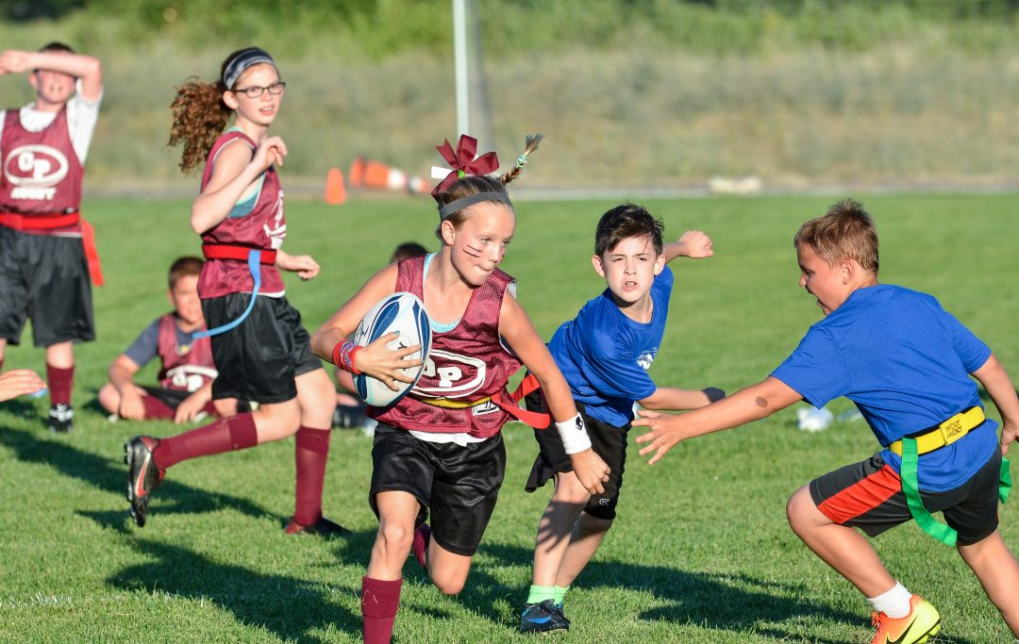
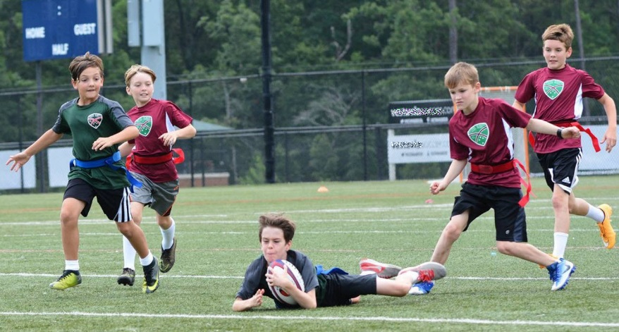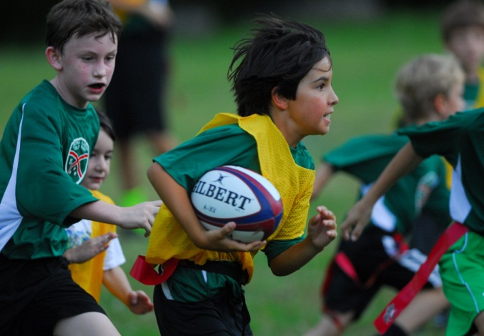
 | U12 (Age 6-11) | U15 (Age 11-14) | U19 (Age 14-18)
Style | CoEd Flag Rugby | Tackle or Flag Rugby 7 on 7 | Tackle Rugby 7 on 7

-To register or see more info about the youth, men’s, or upcoming women’s program visit www.birminghamrugby.com/youth-3/
-or feel free to contact michaellaney@birminghamrugby.org or call 205-903-3408

